**aster yellow**

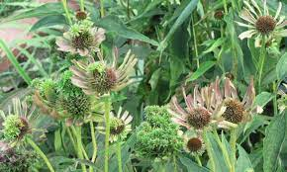

**Aster yellows** is a chronic, systemic plant [disease](https://en.wikipedia.org/wiki/Plant_pathology) caused by several bacteria called [phytoplasma](https://en.wikipedia.org/wiki/Phytoplasma" \o "Phytoplasma).  *Macrosteles quadrilineatus*, moves the aster yellows phytoplasma from plant to plant. The aster yellows disease is caused by the aster yellows phytoplasma (AYP) which is a phloem-limited, bacterium-like organism and is vectored by the aster leafhopper, *Macrosteles quadrilineatus*, a phloem-feeding insect of the order [Hemiptera](https://en.wikipedia.org/wiki/Hemiptera" \o "Hemiptera).

**Prevention**

Aster yellows phytoplasma is a difficult pathogen to control, given its wide host range. Over 300 plant species are susceptible to AYP.[[10]](https://en.wikipedia.org/wiki/Aster_yellows#cite_note-10) Currently, no cure for aster yellows is known.[[3]](https://en.wikipedia.org/wiki/Aster_yellows#cite_note-Hudelson-3) Infected plants and weeds should be removed to eliminate that source of the phytoplasma and minimize spread.[[11]](https://en.wikipedia.org/wiki/Aster_yellows#cite_note-Engel-11) Unfortunately, this is the only control method that home gardeners have available.

**Bacterial wilt**

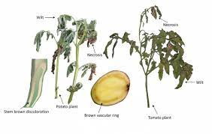

Bacterial wilt is caused by a soil-borne bacterium named Ralstonia solanacearum (formerly known as Pseudomonas solanacearum). Potato wilt bacterium mainly inhabits the roots, and enters the root system at points of injury caused by farm tools or equipment and soil pests.

**Prevention**

Leave machinery taken onto a diseased paddock on the paddock while it's being worked. Load and unload vehicles only in designated areas with sealed or hard ground or bare paddocks away from potato paddocks. After harvest, collect and bury all diseased and discarded tubers at least 1 metre underground.Don't keep any of the produce from a diseased crop as seed.

**rice bacterial blight**

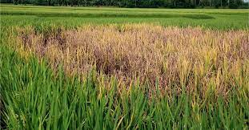

**rice bacterial blight**, also called **bacterial blight of rice**, deadly [bacterial disease](https://www.britannica.com/science/bacterial-disease) that is among the most destructive [afflictions](https://www.merriam-webster.com/dictionary/afflictions) of [cultivated](https://www.merriam-webster.com/dictionary/cultivated) [rice](https://www.britannica.com/plant/rice) (Oryza sativa and O. glaberrima). In severe [epidemics](https://www.merriam-webster.com/dictionary/epidemics), crop loss may be as high as 75 percent, and millions of hectares of rice are infected annually.

**Prevention**

Methods of controlling rice bacterial blight are limited in effectiveness. Chemical control has been largely ineffective in minimizing bacterial blight because of safety concerns, practicality, and bacterial resistance.

**crown gall**

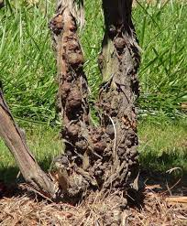

Crown gall is a plant disease caused by the soil-inhabiting bacterium, Agrobacterium tumefaciens. The bacterium causes abnormal growths or galls on roots, twigs, and branches of euonymus and other shrubs primarily in the rose family. The bacterium stimulates the rapid growth of plant cells that results in the galls

**Prevention**

**Prune out infected material.** Crown gall cannot be eliminated from a shrub even though the infected plant may live for many years. **Destroy infected plants.** Destroy the infected plant. The bacterium will remain in the soil so it is important to plant a resistant plant species. **Sterilize the soil.** Soils known to be infected with crown gall bacteria can be sterilized using chemicals, heat, or antibiotics.

**Basal rot**

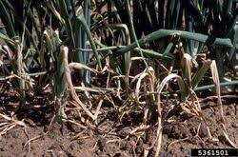

**basal rot**, also called **bulb rot**, [widespread](https://www.britannica.com/dictionary/widespread) [plant disease](https://www.britannica.com/science/plant-disease) caused by a variety of [fungi](https://www.britannica.com/science/fungus) and [bacteria](https://www.britannica.com/science/bacteria) that can infect all flower and crop [bulbs](https://www.britannica.com/science/bulb). Shoots fail to emerge or are stunted, [leaves](https://www.britannica.com/science/leaf-plant-anatomy) are yellow to reddish or purplish, and they later [wilt](https://www.britannica.com/science/wilt) and die.

**Prevention**

Measures taken to fight blister rust include growing resistant varieties, observing strict sanitation measures, and spraying with [fungicides](https://www.britannica.com/science/fungicide). Given that the fungi require an [alternative](https://www.merriam-webster.com/dictionary/alternative) host and cannot spread directly from pine to pine, attempts have been made to [eradicate](https://www.merriam-webster.com/dictionary/eradicate) nearby host plants, but these efforts have proven largely ineffective.

# mosaic

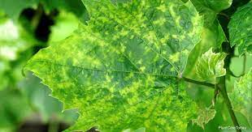

**mosaic**, [plant disease](https://www.britannica.com/science/plant-disease) caused by various strains of several hundred [viruses](https://www.britannica.com/science/virus). A number of economically important crops are [susceptible](https://www.britannica.com/dictionary/susceptible) to mosaic infections, including [tobacco](https://www.britannica.com/plant/common-tobacco), [cassava](https://www.britannica.com/plant/cassava), [beet](https://www.britannica.com/plant/beet), [cucumber](https://www.britannica.com/plant/cucumber), and [alfalfa](https://www.britannica.com/plant/alfalfa). Tulip mosaic virus “breaks” [tulip](https://www.britannica.com/plant/tulip) and [lily](https://www.britannica.com/plant/lily) flowers, causing attractive and colourful streaking.

**Prevention**

Mosaic can be avoided by using virus-free seeds and plants, growing resistant varieties, separating new from old plantings, rotating annuals, and observing stringent sanitation and pest-control measures.

**Psorosis**

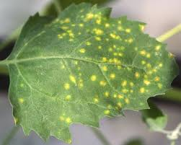

**psorosis**, [disease](https://www.britannica.com/science/disease) of [Citrus](https://www.britannica.com/plant/Citrus) plant species caused by several related [viruses](https://www.britannica.com/science/virus) (family Ophioviridae). Given that the psorosis viruses are largely [transmitted](https://www.britannica.com/dictionary/transmitted) by bud [grafts](https://www.britannica.com/topic/graft) and not by natural vectors, the disease can have significant economic impacts on citrus crops grown from such grafts, including [oranges](https://www.britannica.com/plant/orange-fruit), [grapefruits](https://www.britannica.com/plant/grapefruit), and [tangerines](https://www.britannica.com/plant/tangerine-fruit). Severe infections can [stunt](https://www.britannica.com/science/stunt-plant-disease) growth, and fruit yields may be reduced by one-third or more.

**Prevention**

The disease may be controlled by removing seriously affected trees, planting psorosis-free stock, and using only [scions](https://www.britannica.com/dictionary/scions) and buds from virus-free trees. Quarantine and certification programs exist in many citrus-growing regions to reduce contaminated stock, though many Citrus species can harbour the viruses asymptomatically for more than 10 years.

**Panama disease**

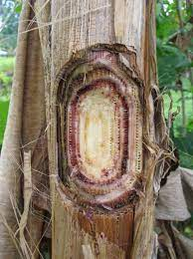

**Panama disease**, also called **banana wilt**, a devastating [disease](https://www.britannica.com/science/disease) of [bananas](https://www.britannica.com/plant/banana-plant) caused by the soil-inhabiting fungus species *[Fusarium oxysporum](https://www.britannica.com/science/Fusarium-oxysporum)* forma specialis cubense. A form of [fusarium wilt](https://www.britannica.com/science/fusarium-wilt), [Panama](https://www.britannica.com/place/Panama) disease is [widespread](https://www.britannica.com/dictionary/widespread) throughout the tropics and can be found wherever susceptible [banana](https://www.britannica.com/plant/banana-plant) [cultivars](https://www.britannica.com/science/cultivar) are grown.

**Prevention**

the best long-term control is to breed and grow highly resistant cultivars, most bananas are [sterile](https://www.britannica.com/dictionary/sterile) and are grown clonally, making the development of new, resistant cultivars difficult. The pathogen cannot be fully controlled with soil [fungicides](https://www.britannica.com/science/fungicide) or fumigants.

### Aphids

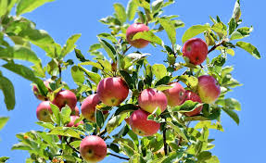

[**Aphids**](https://www.lovethegarden.com/uk-en/garden-problem/aphids) are tiny sap-sucking insects that are almost invisible to the naked eye - but when feeding in clusters are more apparent. Unless controlled effectively, Aphids have the ability to cause plants to wilt, curl and turn yellow. Luckily, aphid numbers can be controlled fairly easily using an [effective insecticide](https://www.lovethegarden.com/product/bugclear-ultra-2-gun-800ml).

**Prevention**

Over watering and over fertilizing can increase aphid populations so only apply the minimum necessary for healthy plant growth. One excellent way to reduce aphid populations is to knock them off with a strong spray of water

### Cabbage root fly

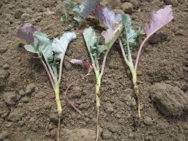

Adult cabbage root flies can look rather like house flies. These garden pests affect the brassica family of cabbages, Brussels sprouts, cauliflower and broccoli. The larvae of the cabbage root fly which resemble white maggots can be very damaging as they eat the roots and stem base. This then leads to wilting and the plants won't recover when watered. Unfortunately, many home garden pesticides are not suitable to use against this pest, so the best to try and limit an infestation is to carry out good crop rotation.

**Prevention**

 Place brassica discs or collars around stems when transplanting seedlings to prevent the adult female fly laying her eggs at the base of the stem. Plants can be protected from attack by covering plants with horticultural fleece, or an insect-proof mesh.